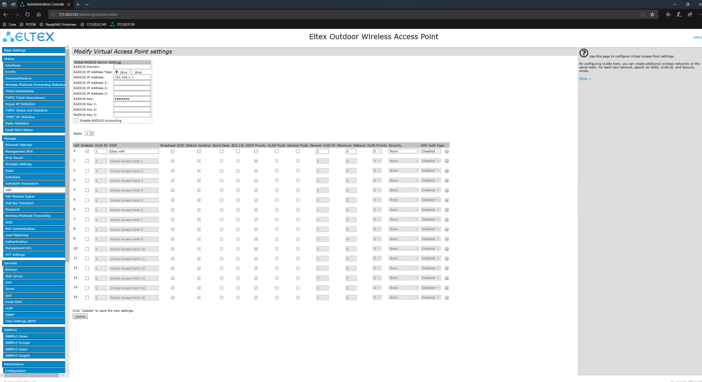
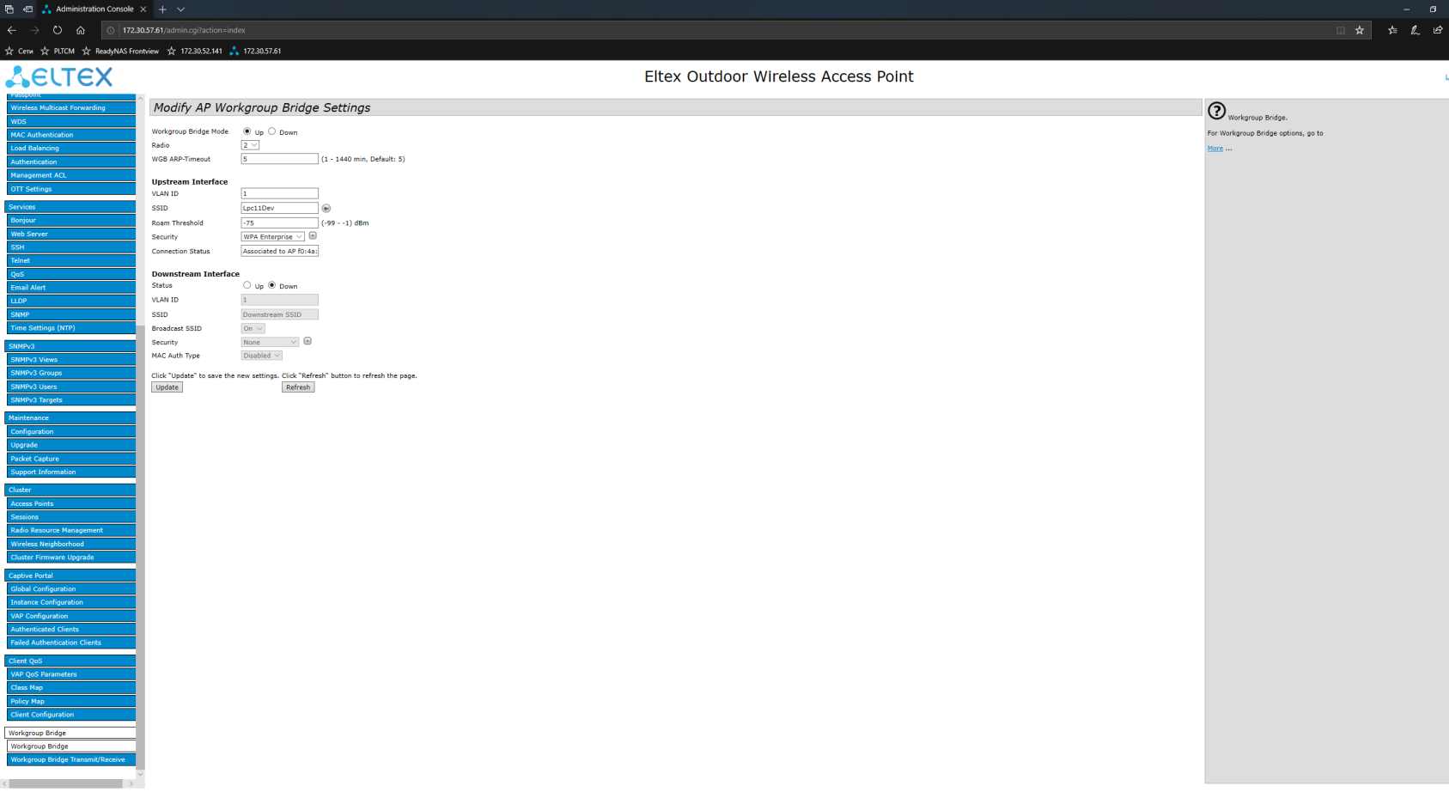
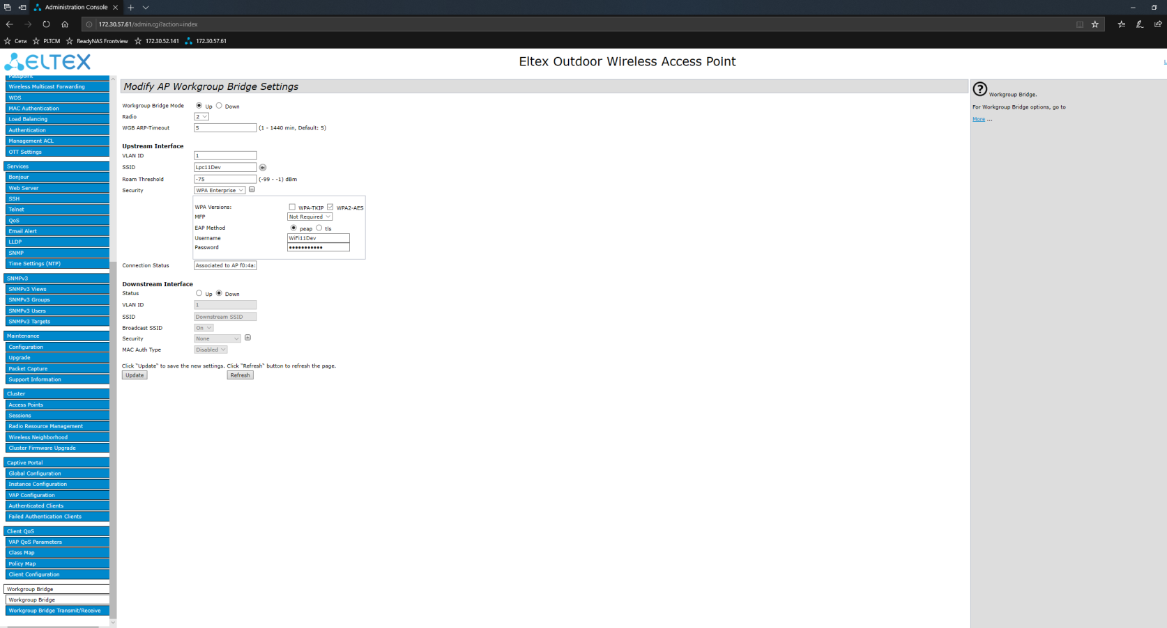
Username: WiFi11Dev
Password: Sensation11
